CREATE JAVA APPLICATION

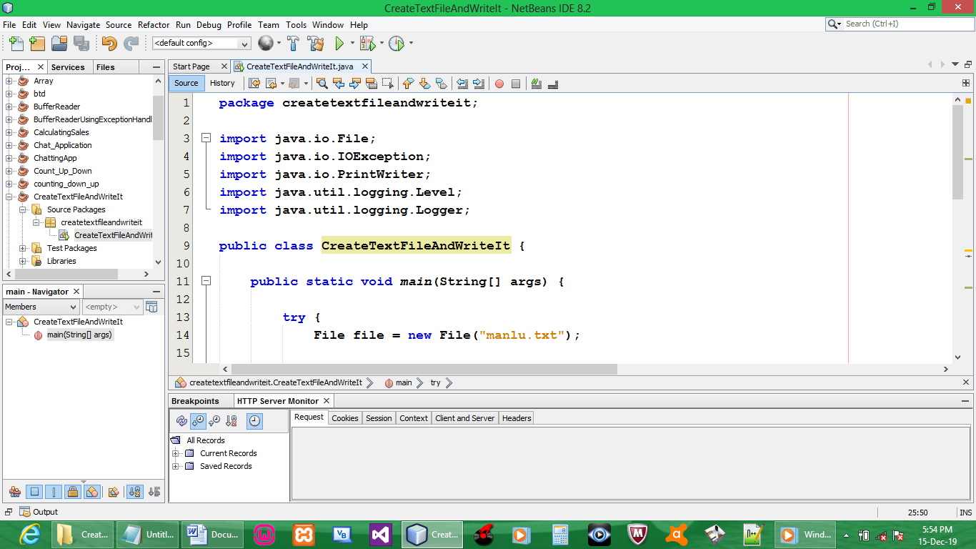

CODE:

package createtextfileandwriteit;

import java.io.File;
import java.io.IOException;
import java.io.PrintWriter;
import java.util.logging.Level;
import java.util.logging.Logger;

public class CreateTextFileAndWriteIt {

public static void main(String[] args) {

try {
File file = new File("manlu.txt");

if (!file.exists()){
file.createNewFile();
}
PrintWriter pw = new PrintWriter(file);
pw.println("ERENG MARKETING NTWANA!!!");
pw.close();
System.out.println("Done");
}
catch (IOException ex) {
Logger.getLogger(CreateTextFileAndWriteIt.class.getName()).log(Level.SEVERE, null, ex);
}
}
}

// creating an object of PrintWriter
// the println will be the content of the file
// when working with files, you need to close() the file
// DONE is to show that the program has executed successfully
// To find the location of the project. Right click the project, Go to properties & copy the path & then paste the path on your folder explorer & press enter

OUTPUT:

Successfully executed
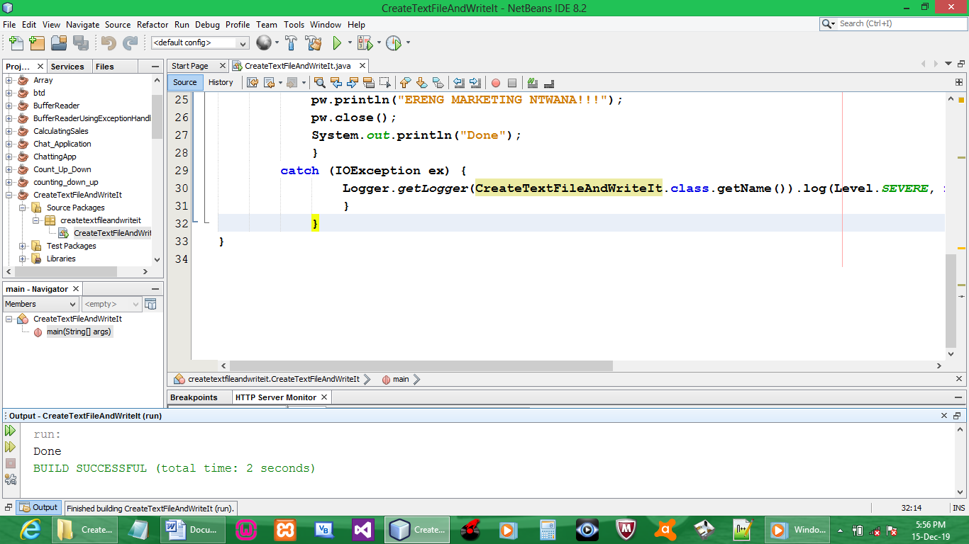

File created
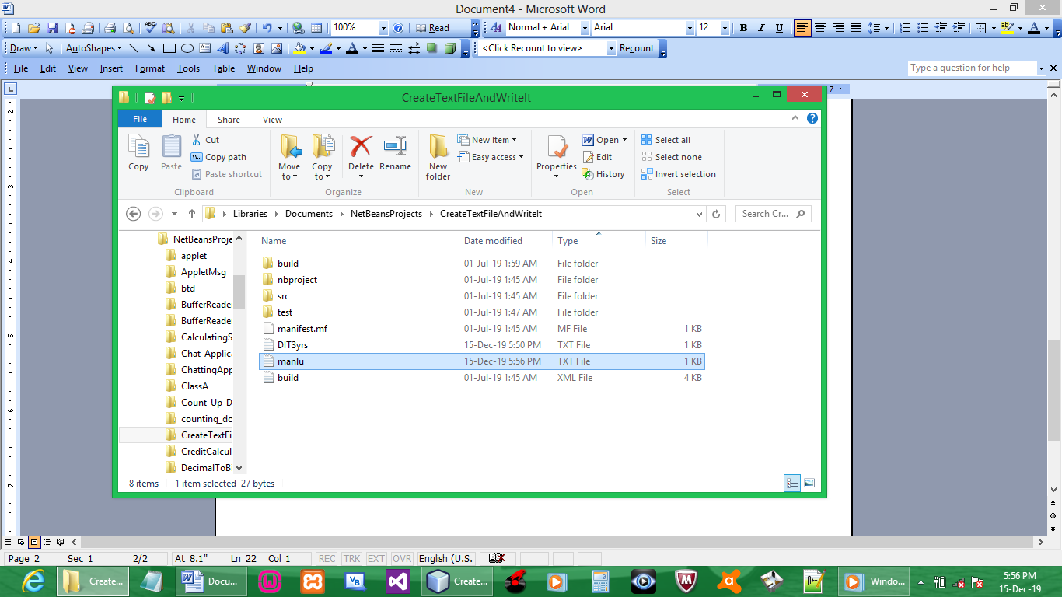

File content
